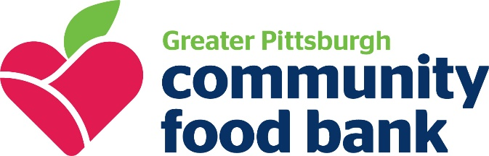
CONTACT:
Christa Johnson
Communications and Public Relations Specialist
412.460.3663 etx. 452
cjohnson@pittsburghfoodbank.org

FOR IMMEDIATE RELEASE

Food Bank asks for community feedback

PITTSBURGH, PA (November 2, 2021) When the pandemic hit, many people in our community crossed paths with Greater Pittsburgh Community Food Bank (The food bank). Through food resources, volunteering and donations, our community has played a critical role in feeding our neighbors and implementing innovative programs to knock down a variety of hurdles in access food resources. As we continue our mission, the food bank is looking for feedback though a new survey.
The goal of this survey is to get an authentic look at ways we can make our programs more effective to meet the needs in our 11-county service area.
“We want to hear from anyone who supports the Food Bank's mission of feeding people in need and mobilizing the community to eliminate hunger. With your input, we can continue to strengthen our efforts to meet the needs of communities across southwestern PA,” said Stakeholder Engagement Initiative Project Manager Erin Spangler.
This survey is part 2 of a 3-part effort to engage our community. The survey will be open through November 12th. To participate, please visit pittsburghfoodbank.org/feedback
xxx
About Greater Pittsburgh Community Food Bank
Greater Pittsburgh Community Food Bank is a nonprofit organization that distributes food for more than 45 million meals annually across 11 counties in southwestern Pennsylvania through a network of more than 850 agencies, partners and programs. The Food Bank was founded in 1980 and is a member of Feeding America, the leading domestic hunger-relief charity in the U.S. For more information on hunger in our region or how to get involved, visit pittsburghfoodbank.org.

